Goto notification center and observe that save changes button enabled always: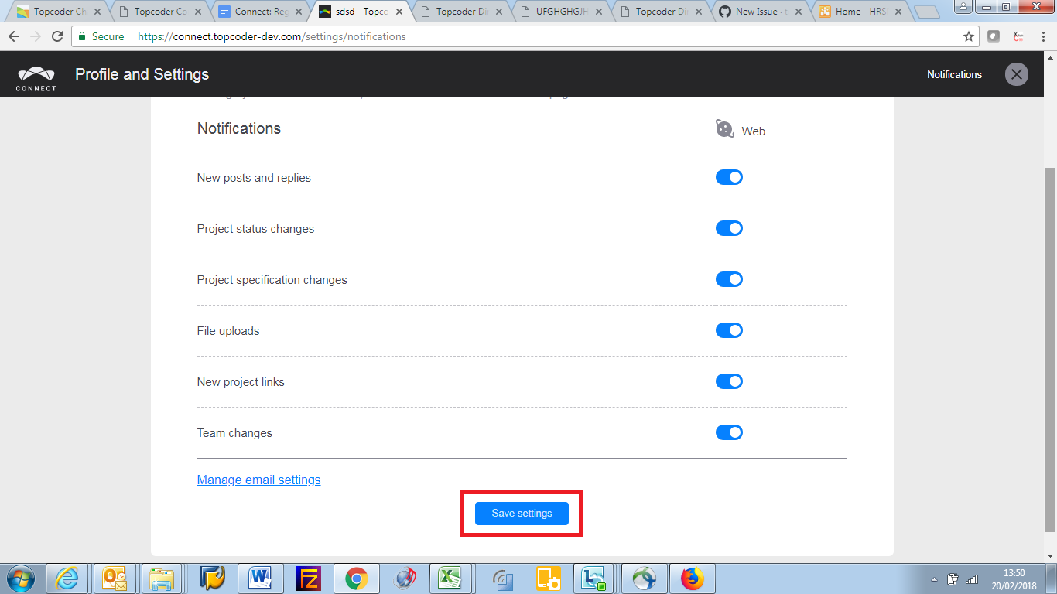

Click on Save settings buttons without making any changes and observe the message: